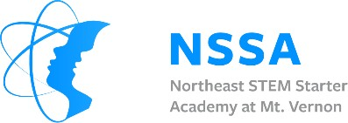

2022 NSSA Science and Engineering Research Fair

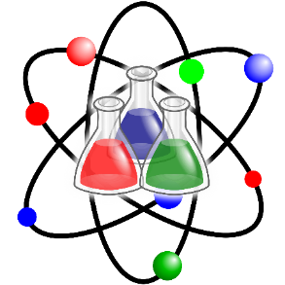 | 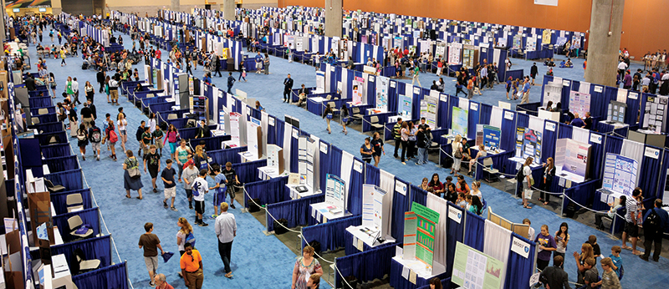
Eight years since our launch, the NSSA continues our focus on delivering enhanced, experiential STEM learning programs. Over the years, our programs have engaged more than 3,000 students in more than 80 different classes. With the help and support of Regeneron Pharmaceuticals, we are excited to announce a district-wide Science and Engineering Research Fair for the community we love and hold dear, Mt. Vernon, NY. The NSSA’s first science fair program will create opportunities for students currently in 6th, 7th, 8th, 9th and 10th grades to learn and apply the scientific method to conduct independent research. The results of each group of two students’ research will be presented in a district-wide science fair event scheduled for Saturday, May 21, 2022. At the final event, students will display the product of their efforts and participate in interviews by a panel of judges to determine scientific merit. Students who have been judged to have used the scientific method properly and demonstrated thoroughness in their studies and endeavors will be awarded prizes and awards. The NSSA will award more than $7,500.00 to the students participating in the program. All attending students will also receive a $25.00 Amazon Gift Certificate!
Twenty students from each of the five grades levels, only students who live in Mt. Vernon School, will be accepted this year to participate in this, our first year of the program. The students who apply first will be accepted until twenty students from each grade are accepted. The twenty students in each grade level will be assigned to work with another student to create ten teams of two students in every grade level to learn the science and engineering research methodology and approach. Each of the five grades of students will be assigned one educator and a class assistant who will work closely with the ten teams in their group to learn and move through each step of the process that will conclude in a final, all-day fun competition. While all 100 students accepted in the program will be recognized and rewarded for their efforts, the members of the top three teams in each of the five grade levels will win additional recognition and prizes. Further information about the program will be provided to all accepted students and their parents. Students should complete the application on the NSSA website, www.nssa-mv.org, under the green tab on our home page: “2021 NSSA Science & Research Fair”. Student applications can now be submitted. Additional information, including important dates, is available on the NSSA website.
Thank you, and the NSSA looks forward to a tremendous learning experience for our students.

Don't hesitate to contact Gerald Dennis, NSSA, Executive Director, 914-888-7556, gdennis@nssa-mv.org

Northeast STEM Starter Academy at Mt. Vernon 2022 Science &
Engineering Research Fair

#1- Session-Tuesday-Q&A  #2- Session-Thursday-Q&A | #1-February 15, 2022- 7:30 PM to 8:30 PM  #2-February 17,2022- 7:30 PM to 8:30 PM | These two Program Introductory Sessions are intended for students and parents who have signed up to join the program. Parents and students will be provided the opportunity to have questions addressed and confirm how the program will be conducted. The meeting will be done on Zoom, the access information will be emailed to all students and parents. Both sessions will be focused on providing the same information to attendees so no need to attend both sessions. A Zoom link will be sent to access the sessions. The sessions are voluntary and will not affect the student’s participation in the program.
Mt. Vernon 2022 Science & Engineering Research Fair Program Schedule
Tuesday, Session #1 | March 1, 2022 | 4:15 to 5:45 | Virtual (Research Notebook Delivered to Schools)
Thursday, Session #2 | March 3, 2022 | 4:15 to 5:45 | Virtual (Weekend- Students Project Review)
Tuesday, Session #3 | March 8, 2022 | 4:15 to 5:45 | Virtual (Project Student Project Selection- Supplies Order)
Thursday, Session #4 | March 10, 2022 | 4:15 to 5:45 | Virtual
Saturday, Session #5 | March 12, 2022 | 10:00 to 12:30 | In-Person- (To be confirmed) Lunch will be provided. (Supplies Delivered)
Tuesday, Session #6 | March 15, 2022 | 4:15 to 5:45 | Virtual
Thursday, Session #7 | March 17, 2022 | 4:15 to 5:45 | Virtual
Saturday, Session #8 | March 19, 2022 | 10:00 to 12:30 | In-Person- (To be confirmed) Lunch will be provided.
Tuesday, Session #9 | March 22, 2022 | 4:15to 5:45 |  | Virtual
Thursday, Session #10 | March 24, 2022 | 4:15 to 5:45 |  | Virtual
Saturday, Session #11 | March 26, 2022 | 10:00 to 12:30 |  | In-Person- (To be confirmed) Lunch will be provided.
Tuesday, Session #12 | March 29, 2022 | 4:15 to 5:45 |  | Virtual
Thursday, Session #13 | March 31, 2022 | 4:15 to 5:45 |  | Virtual
Tuesday, Session #14 | April 5, 2022 | 4:15 to 5:45 |  | Virtual
Thursday, Session #15 | April 7, 2022 | 4:15 to 5:45 |  | Virtual
Tuesday, Session #16 | April 19, 2022 | 4:15 to 5:45 |  | Virtual
Thursday, Session #17 | April 21, 2022 | 4:15 to 5:45 |  | Virtual
Saturday, Session #18 | April 23, 2022 | 10:00 to 12:30 |  | In-Person- (To be confirmed) Lunch will be provided.
Tuesday, Session #19 | April 26, 2022 | 4:15 to 5:45 |  | Virtual
Thursday, Session #20 | April 28, 2022 | 4:15 to 5:45 |  | Virtual
Saturday, Session #21 | April 30, 2022 | 10:00 to 12:30 |  | In-Person- (To be confirmed) Lunch will be provided.
Tuesday, Session #22 | May 3, 2022 | 4:15 to 5:45 |  | Virtual
Thursday, Session #23 | May 5, 2022 | 4:15 to 5:45 |  | Virtual
Saturday, Session #24 | May 7, 2022 | 10:00 to 12:30 |  | In-Person- (To be confirmed) Lunch will be provided.
Tuesday, Session #25 | May 10, 2022 | 4:15 to 5:45 |  | Virtual
Thursday, Session #26 | May 12, 2022 | 4:15 to 5:45 |  | Virtual
Saturday, Session #27 | May 14, 2022 | 10:00 to 12:30 |  | In-Person- (To be confirmed) Lunch will be provided.
Tuesday, Session #28 | May 17, 2022 | 4:15 to 5:45 |  | Virtual
Thursday, Session #29 | May 19, 2022 | 4:15 to 5:45 |  | Virtual
Saturday- Program Fair Event | May 21, 2022 | 9:30 AM to  7:00 PM |  | NSSA Science & Engineering Research Fair  Over $7500.00 in Awards and Prizes will be distributed to our students.

